**6.8 UAS Traffic Management**

The *Traffic Management* for UAS is based on existing Air Traffic Management System for manned aviation [1]. The controlled airspace segments are *static* and have one *authority for one zone* principle. The dynamic zones have been proposed in [2]. However, it will be omitted for *simplification purpose*. The necessity for *UAS integration* into *National Airspace* has been outlined in [3].

The latest *Airbus blueprint* [4] outlines some functionality. The main purpose of this section is to show *Reach Set based Approach* capability to follow *Usual Air Traffic Management* commands.

The *section* is organized to introduce:

1. *UTM Architecture* (sec. 6.8.1) - centralized ATM-like authority over airspace cluster.
2. *Cooperative Conflict Resolution* (sec. 6.8.2) - the model used for conflict resolution in *controlled airspace*.
3. *Non-Cooperative Conflict Resolution* (sec. 6.8.3) - the model used for conflict resolution in *non-controlled* airspace and *emergency avoidance*.
4. *Handling Standard Collision Situations* - head-on approach (sec. 6.8.4), converging situation (sec. 6.8.5), overtake (sec. 6.8.6).
5. *Position Notification* (sec. 6.8.7) - position notification design.
6. *Collision Case* (sec. 6.8.8) - calculation and handling of *collision situations*.
7. *Weather Case* (sec. 6.8.9) - definition and handling of *weather hazards*.

# 6.8.1 Architecture

**UTM Concept** is based on *asynchronous event-based control* [5]. *Event* in *controlled airspace* is handled in the form of *cases* [6]. There are following *event sources*:

1. *Weather Information Service* (from [7]) - used to create *weather case* (tab. 6.4).
2. *Position Notification from UAS systems* (tab. 6.1) - used to create *collision cases* (new functionality) (tab. 6.3).

**Decision Frame** (eq. 6.1). The *UTM* is operating in discrete decision frames which are starting on current *decision time* and ending at next *decision time*:

*decisionFramei* = [*decisionTimei,decisionTimei*+1[*, i* ∈ 1*,...,k,k* ∈ N+ (6.1) **Event-based Airspace Control** is collecting events in previous *decisionFramei*−1 and issuing commands in current *decisionFramei*.There are following phases during the *UTM frame* cycle:

1. *Planning* - the detection phase, when the hazardous situations are assessed.
2. *Fulfillment* - the monitoring phase, when controlled UAS systems full fill the state of affairs for directives and mandates.
3. *Acknowledgment* - the closing phase, when UTM assess and acknowledges the performance of controlled UAS systems.

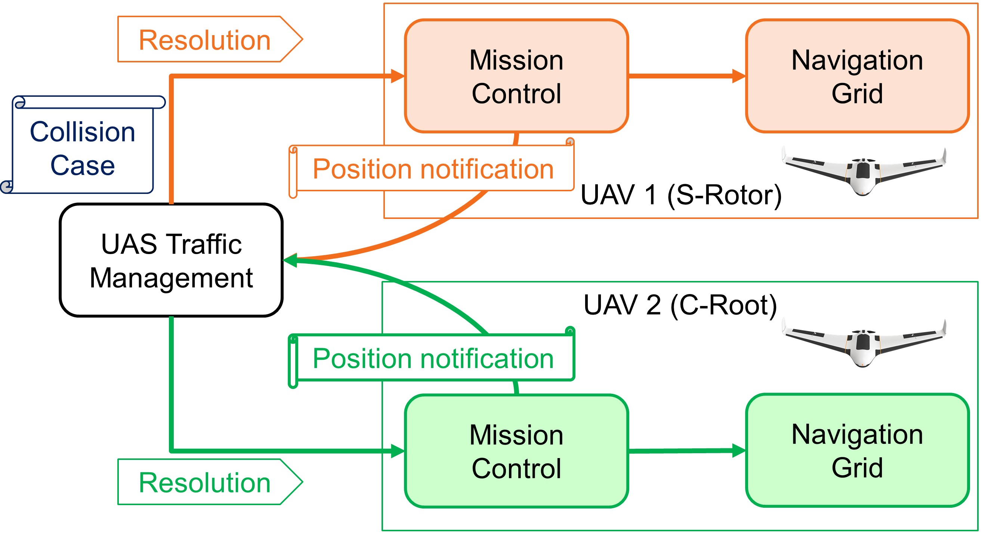

Figure 6.1: UAS Traffic Management (UTM) architecture overview.

**Architecture** (fig. 6.1). There are multiple UAS systems equipped with standard *Mission Control* and *Navigation* procedures.

Depending on the *airspace cluster* decision time frame they are sending *periodical position notifications* (tab. 6.1).

The *UAS Traffic Management* (UTM) collects the event data from *Weather Information Service* and *Position Notifications* calculating respective *cases*.

If there is an *active collision/weather case,* the *UTM* will send *resolutions* to respective airspace attendants.

# 6.8.2 Cooperative Conflict Resolution

**Idea:** There is a *final decision maker* (absolute authority) in conflict resolution. This authority is *UTM* or *air traffic attendant* with higher priority. The future *UTM system* is such authority. The approach to mixed conflict resolution is mentioned in [8], based on navigation [9]. This is similar to our approach.

*Note. Open Issue:* Decentralized model with UTM as an approver of directives is possible, but that is a topic for own research.

**Goal:** UAS is obligated to follow up committed mission plan with given precision. There is one to five percent allowed deviations for ATM mission plans. Similar rates are achievable according to [8]. This requirement is given by [1] ICAO 4444 document for ATM operations.

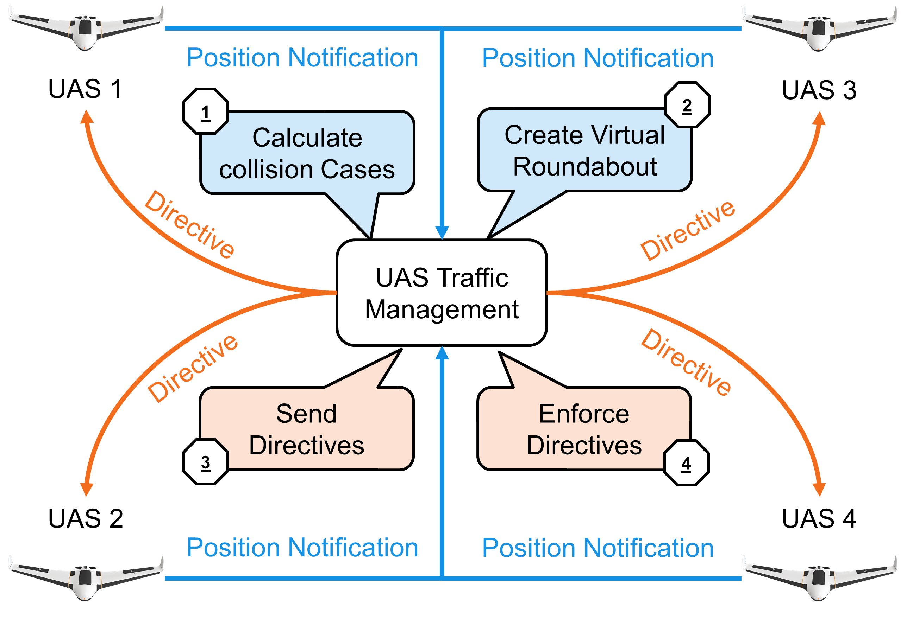

Figure 6.2: Cooperative conflict resolution via UTM authority.

**Cooperative Conflict Resolution** (fig. 6.2) shows a functional diagram of one *UTM time-frame* there are following actors:

1. *Unmanned Autonomous System* (UAS) equipped with necessary navigation and communication modules, providing the unique *identification number*.
2. *UAS Traffic Management* (UTM) posing as the central authority for given *airspace cluster*.

The following steps are executed during *Cooperative conflict resolution*:

1. *UAS*∗ → *UTM Send position notification* - each *UAS* is notifying the authority (UTM)
2.  *Calculate collision Cases* - UTM gathers data and predicts possible collisions then it tries to link them and manage the situation.
3. *UTM Create virtual Roundabout* - active collision cases are aggregated into a virtual roundabout.
4. *UTM* → *UAS*∗ *Send directives* - UTM sends commands to UAS systems which need to change their planned trajectories.
5. *UTM* → *UAS*∗ *Enforce directives* - UTM is periodically checking constraints imposed in previous *decision frames*.

# 6.8.3 Non-Cooperative Conflict Resolution

**Idea:** There is *main UAS(1)* which is flying in open *non-controlled* airspace. Other UAS areoperating in its vicinity. It is expected that they are claiming their *planned trajectories*. The *Main UAS(1)* detects the collision with other *UAS*(2-4).

There is no *final decision maker* nor *supervising authority*; all communication participants have a similar level of rights.

*Note.* There is an assumption that other airspace users are behaving like intruders, without intent to destroy or harm. The *adversarial behavior* is not accounted. The response from an *intruder* is not mandatory in *non-controlled* airspace.

**Goal:** Provide *mutual avoidance mechanism* in *non-controlled* airspace. Let us consider the equal standpoint of all airspace attendants.

**Conflict Resolution:** The conflict resolution depends on current mode and *handshake* between airspace attendants. The non-cooperative behavior has been implemented as follows:

1. *Navigation mode* - every *airspace attendant* is calculating own *collision cases* and checking the behavior of the other (virtual UTM).
2. *Emergency avoidance mode* - is depending on communication mode:
   1. *Response mode* - claiming separation methods and using avoidance mechanism (Avoidance grid with intruder model in our case).
   2. *Blind mode* - every conflict side picks own strategy respecting given *rules of the air*.

*Note. Intruder Intersection model selection:* UAS based on Event detects possible collision for some reason UTM directive is out of the question, then try to claim separation (body volume intruder model (sec. **??**)), If separation fails, go full survival mode (uncertain intruder model (sec. **??**)).

**Special Cases in Manned Aviation:** There are IFALPA reports which can give us an overview of *enforced non-cooperative* mode causes in *controlled airspace*:

1. *VFR disabled* - flying in fog or thick clouds can render pilot vision, similar to UAS cameras/LiDAR.
2. *IFR equipment broke* - the sensor malfunction is more likely to happen due to the lesser redundancy in UAS systems.
3. *C2C Link disabled* - communication loss is more likely to happen, due to the lesser redundancy.
4. *ATM failure* - the ground control module of UTM can also fail.

*Note.* Traffic management related fails are lesser than 0.001 cases per one flight (according to IFALPA [10]).

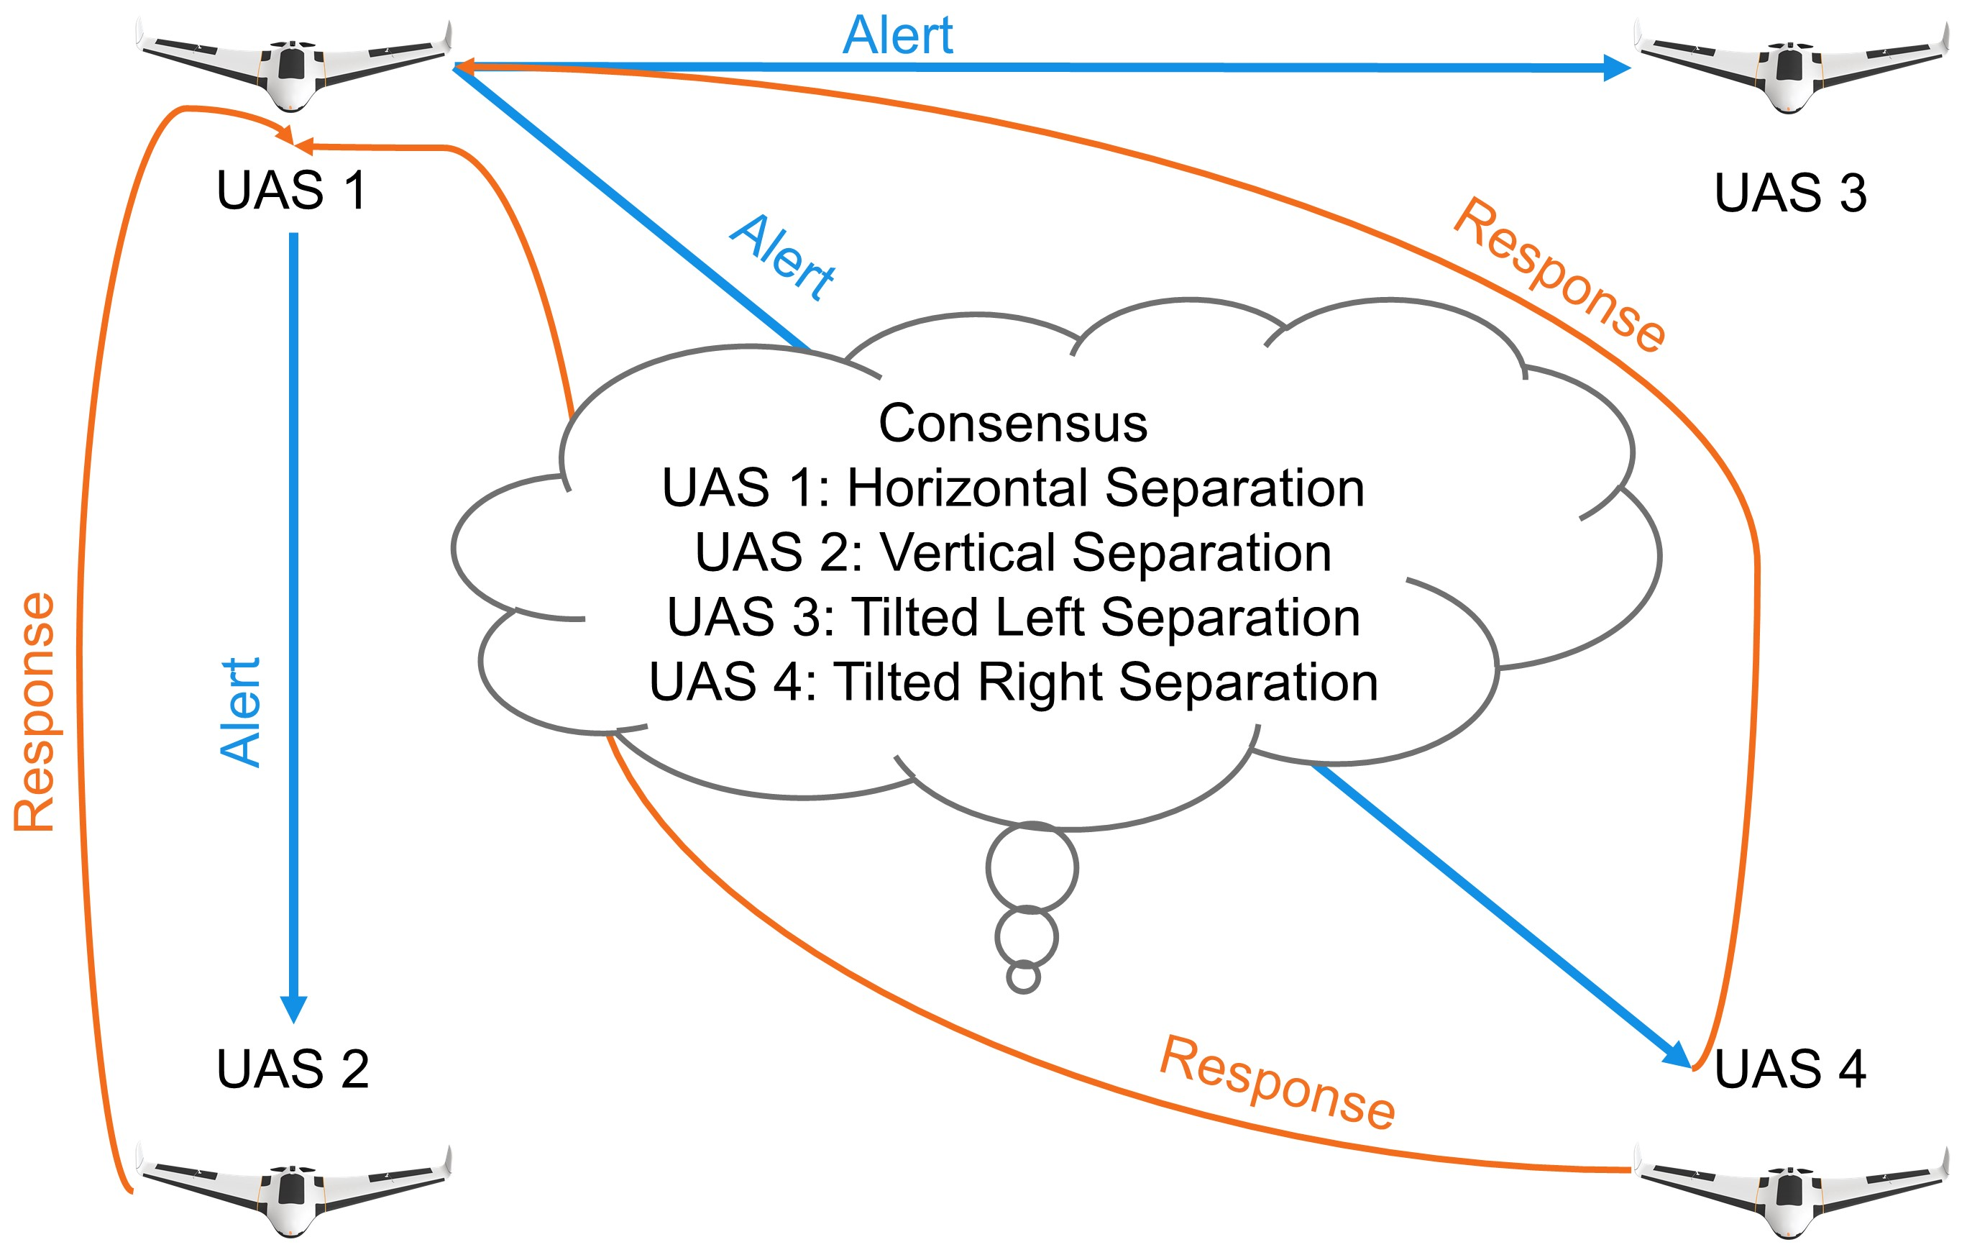

Figure 6.3: Non-cooperative conflict resolution via UAS claims.

**Response mode scenario example:** The *main UAS(1)* is going to collide with other *UAS*(2-4):

1. *UAS*(1) → *UAS*(2 − 4) sends position and heading notification.
2. *UAS*(2 − 4) calculates possible collisions.
3. *UAS*(2−4) → *UAS*(1) sends a response to the *main UAS(1)* with claimed separation mode.
4. (1) acknowledges proposed *separation modes*.
5. 4) avoids each other using claimed separation mode because every *UAS* achieved *consensus*.

*Note.* The mutual consensus is not usually achieved via C2 communication. The most common case is *assuming separation mode*. This case is shown in (sec. **??**)

# 6.8.4 Handling Head on Approach

**Goal:** Identify required parameters sufficient for automatic solution of *Head on collision* situation.

**VFR:** The *Visual Flight Rules* (VFR) are specified in annex 2 [11], and there is a *Head on* approach for two or more air crafts. The definition is rather vague: ”The pilot should diverge from original heading to the right to create sufficient, safe space for avoidance.”

**IFR:** The *Instrument Flight Rules* in annex 2. [11] and 11. [12] are defining the boundaries and events for success full *Head on resolution* in larger detail.

The parameter values are useless due to the UAS scaling factor; the following parameters can be used in UTM:

1. *The angle of approach* ≥ 130◦ - the minimal planar angle between aircraft positions and expected collision point is in the interval [130
2. *Minimal detection range* - the minimal detection range of head-on collision is 2 × *turningRadius* + *safetyMargin*.
3. *Safety margin* - during avoidance all aircraft keeps mutual distance at least the value of safety margin.

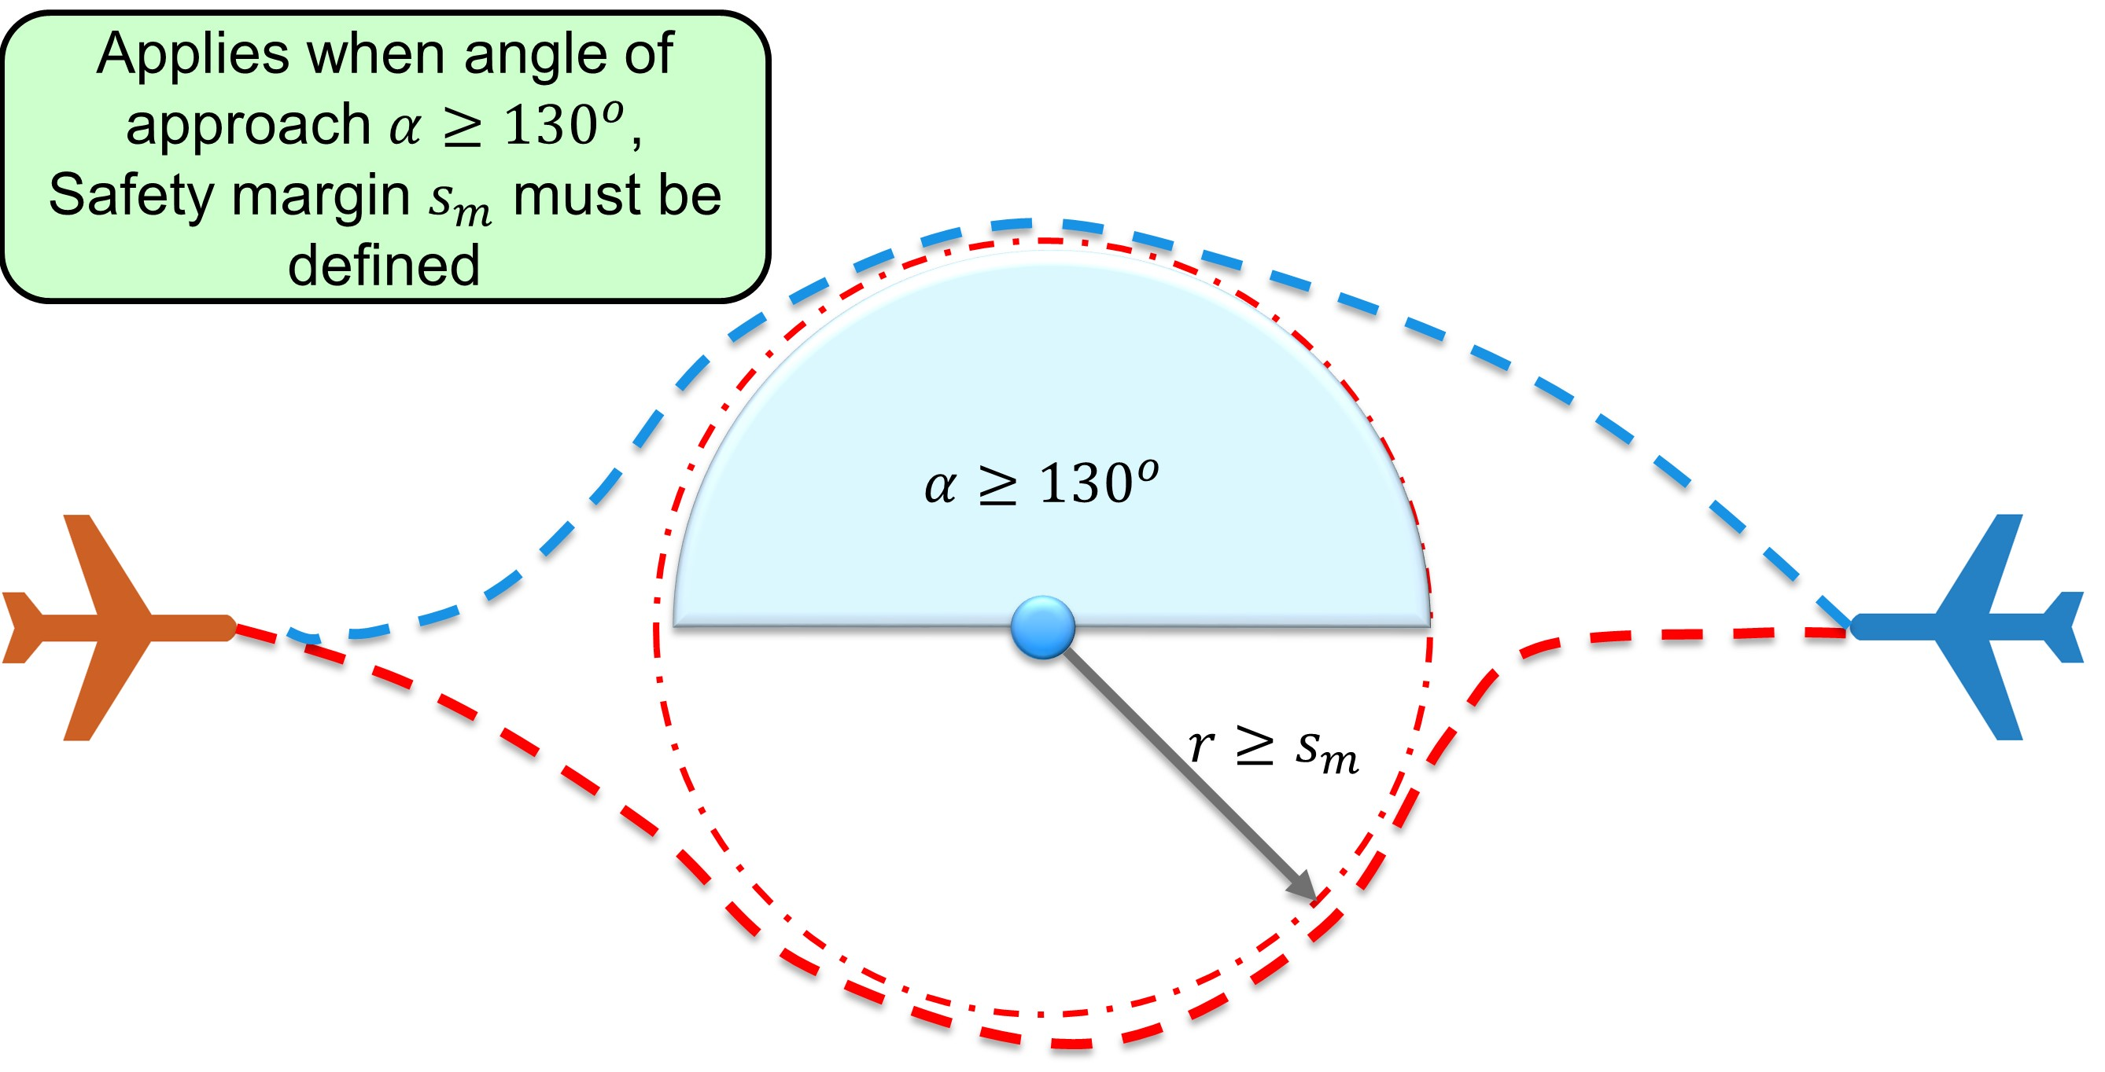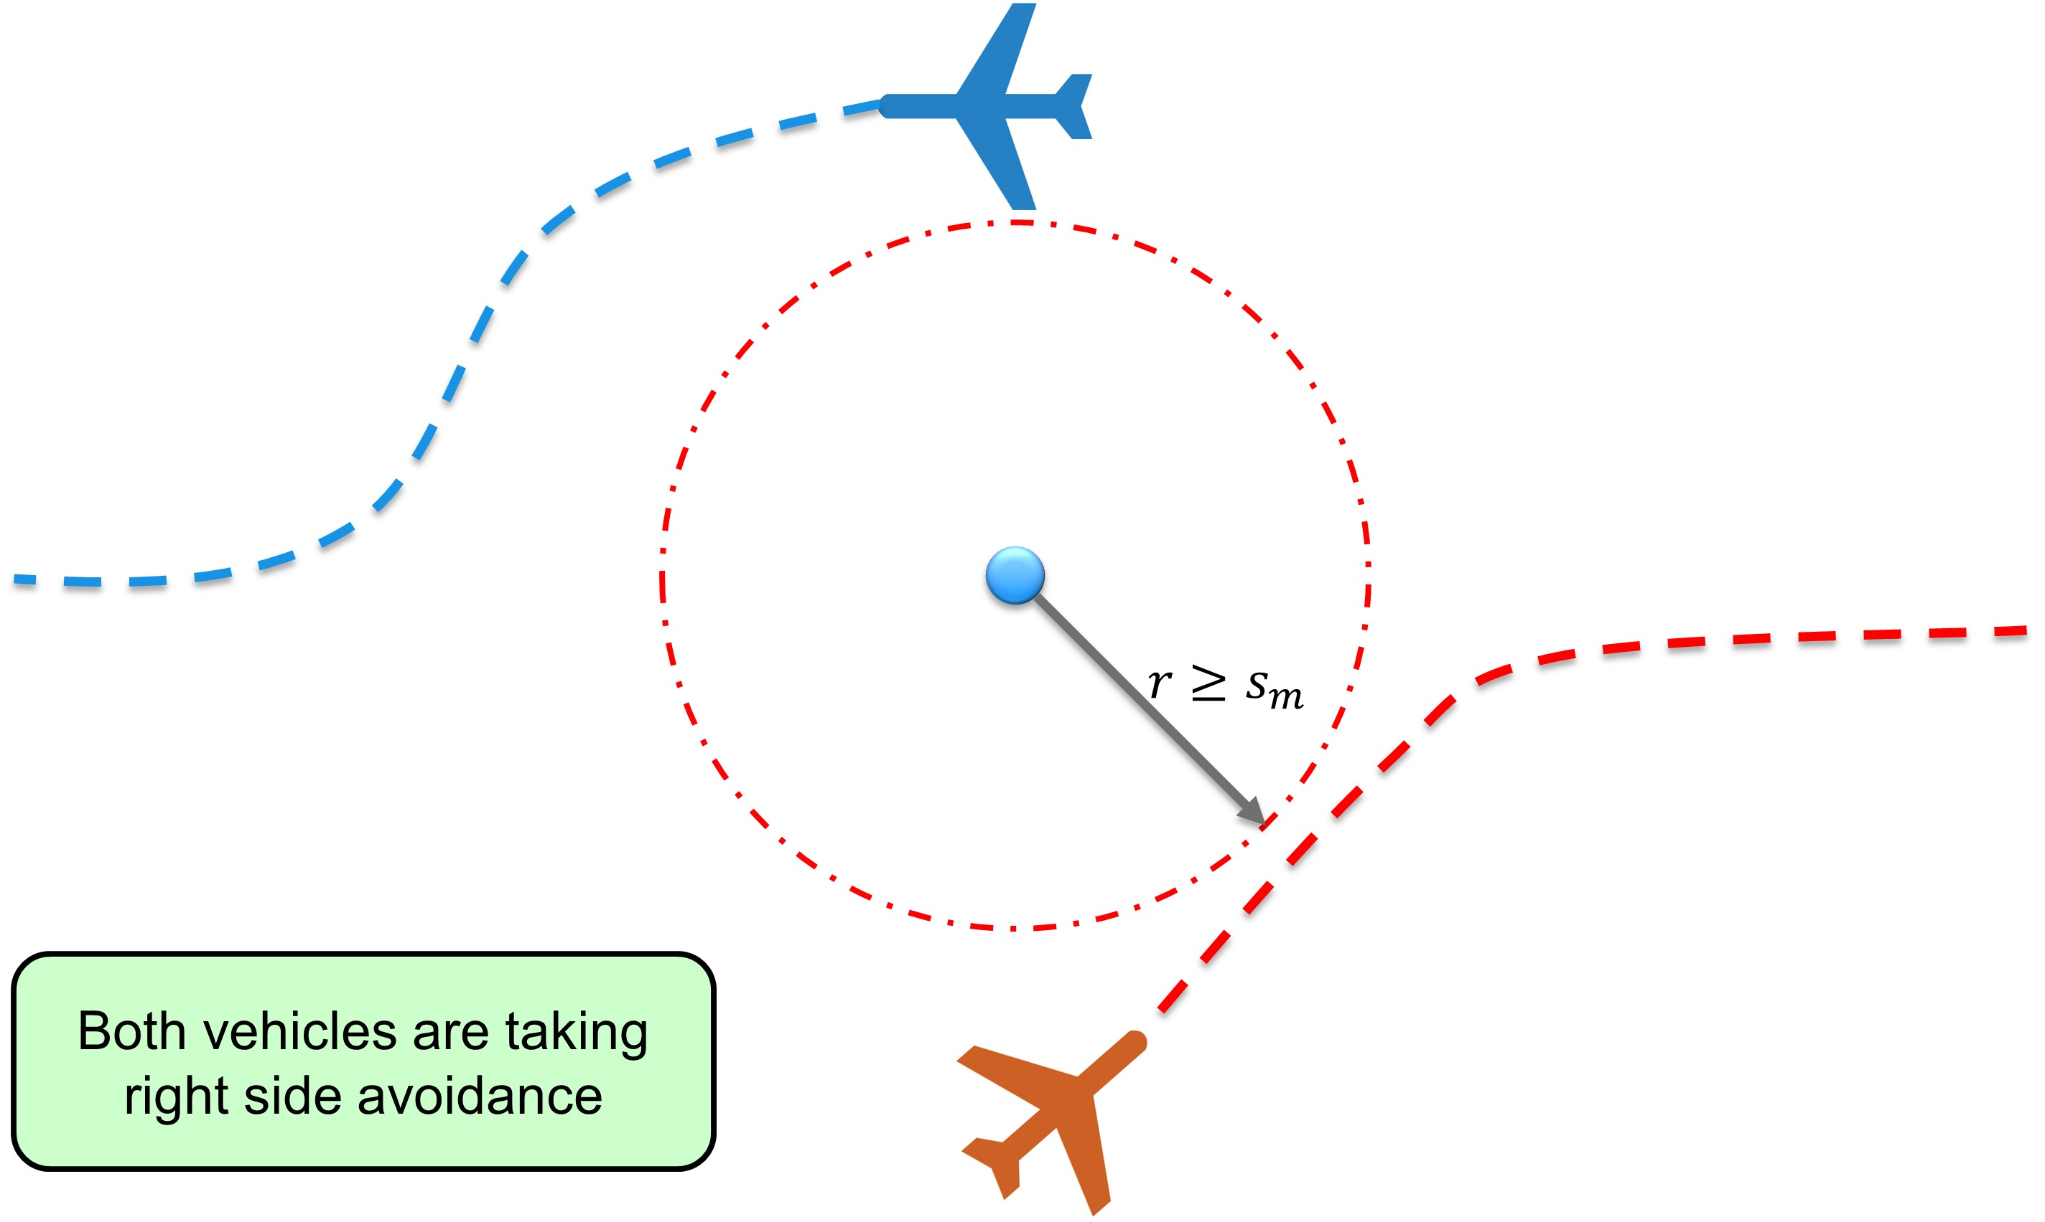

(a) Detection. (b) Resolution/Closing.

Figure 6.4: Head on approach detection/resolution/Closing

**Triggering Events:** The *head-on approach* (fig. 6.4) *triggering events* are the following:

1. *Detection* (fig. 6.4a) - the *collision case* is open when *collision point* with the respective angle of approach is detected. This must happen until the *point of no return* is achieved.
2. *Resolution* (fig. 6.4b) - the *virtual* roundabout is enforced until the closing condition is met.
3. *Closing* (fig. 6.4b) - based on the condition that all vehicles are heading away from *collision point* and their mutual heading is neutral or opposite.

**Virtual roundabout:** The *flight levels* can be abstracted as the *virtual 2D surface*. The *airspace attendants* are moving on virtual routes which can cross each other. The idea is to create virtual roundabout with enforced velocity to enable smooth collision avoidance.

1. *Center* - the center defined in *airspace cluster* local coordinate system (flight level defining the horizontal placement).
2. *Diameter* - the minimal distance to *center*, accounting the *wake turbulence* and another phenomenon.
3. *Enforced velocity* - all attendants at *virtual roundabout* keeps the same velocity. It helps to keep constant mutual distances.

# 6.8.5 Handling Converging Maneuver

**Goal:** Identify *required parameters* sufficient for automatic solution of *Converging Maneuver*.

**VFR:** The *Visual Flight Rules* (VFR) are specified in annex 2 [11]. The rule is different from *Head on Approach* (sec. 6.8.4) because multiple roles are depending on relative aircraft position:

1. *Avoiding Aircraft* - there is an aircraft on the relative right side (blue).
2. *Right Of the Way (ROA) Aircraft* - there is an aircraft on the relative left side (red).

The *avoiding aircraft* should take the *right of the way aircraft* from behind, with sufficient *safety margin*, and return to original *heading* afterward. The *magnitude* of *avoidance curve* must consider *wake turbulence* and other impacts of *avionic properties*.

*Note.* This rule is applied only when both *aircraft* belong to the same *maneuverability class* [11].

**IFR:** The *Instrument Flight Rules* in annex 2. [11] and 11. [12] are defining *converging maneuver* in detail.

The *parameters* from a *head-on approach* can be reused:

1. 70◦ ≤ *The angle of Approach <* 130◦ - the minimal planar angle between aircraft position and expected collision point is in the interval [70
2. *Minimal detection range* - given as *turningRadius* + *safetyMargin*, while *safety margin* is accounting all impact factors.
3. *Safety margin* - during avoidance all aircraft keeps mutual distance at least on the value of *Safety Margin*.

*Note.* The lesser *angle of approach* induces stronger wake turbulence impact on avoiding aircraft. This results in an increase of *safety margin*.

The *wake turbulence* is represented as a droplet at the back of the plane. *Wake turbulence range* can be calculated based on wake turbulence cone.

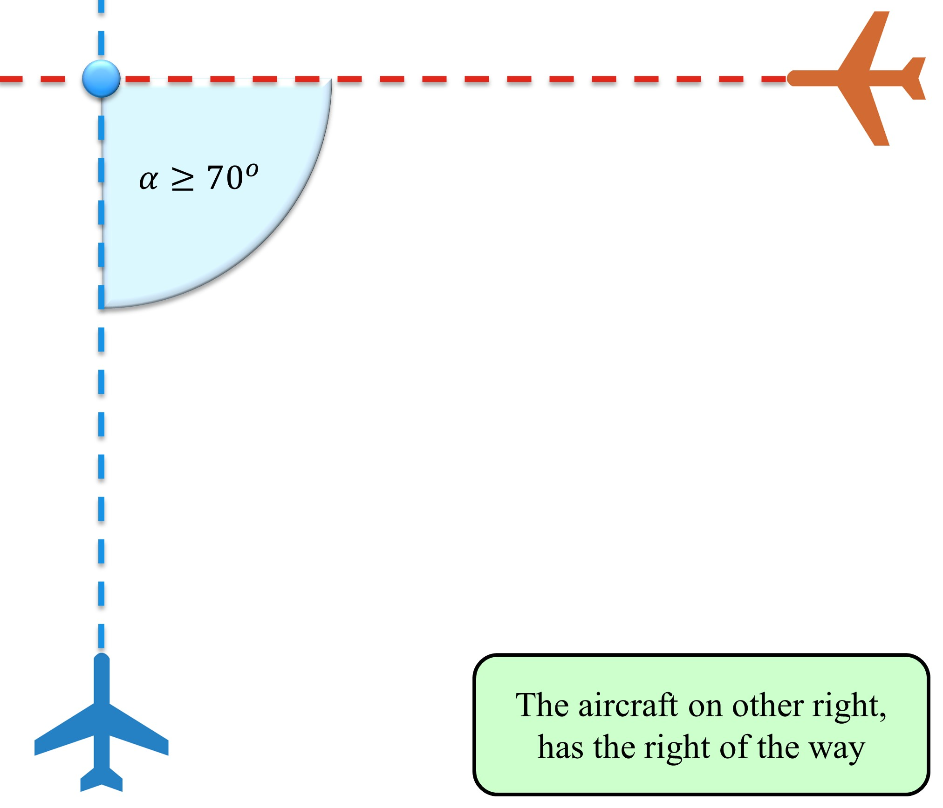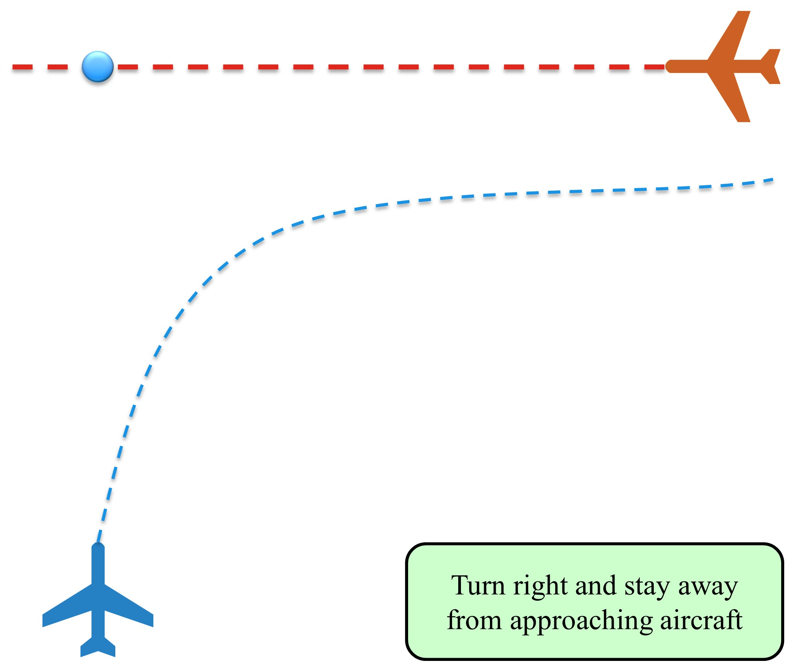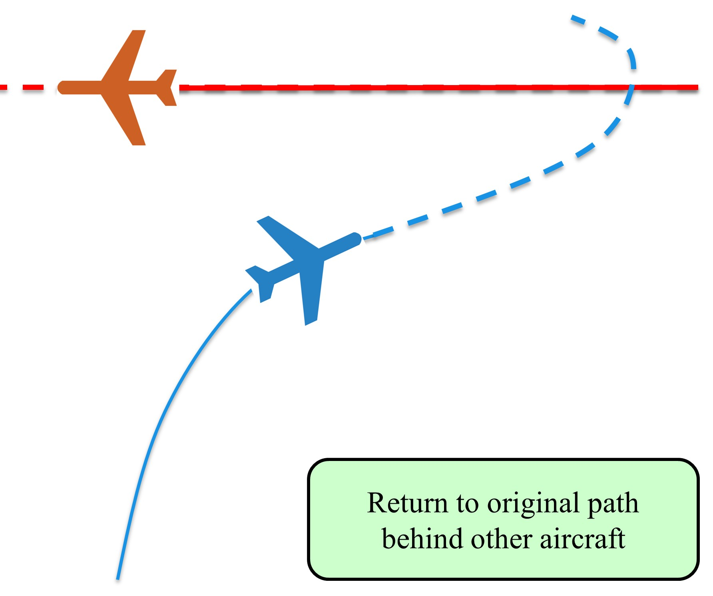

(a) Detection. (b) Resolution. (c) Closing

Figure 6.5: Converging maneuver Detection/Resolution/Closing

**Triggering Events:** The *converging maneuver* (fig. 6.5) *triggering events* are the following:

1. *Detection* (fig. 6.5a) - The *avoiding airplane* (blue) detects *collision point* (blue circle) which satisfy the *converging maneuver conditions*. The distance between *aircraft position* and *collision point* is lesser than the *detection range*.
2. *Resolution* (fig. 6.5b) - the *Right Of the Way aircraft* (red) stays at the original course. The *avoiding aircraft* (blue) follows the *parallel* to another *plane*. The distance of *avoiding plane* to *other plane trajectory* is greater or equal to *safety margin*.
3. *Closing* (fig. 6.5c) - when both planes have an opposite heading, and they miss each other the converging maneuver can be closed. The *avoiding airplane* will return to *original trajectory* while keeping the distance from an*other plane* (red) at greater or equal to *safety margin*.

# 6.8.6 Handling Overtake Maneuver

**Goal:** Identify *required parameters* sufficient for automatic solution of *Overtake Maneuver*

**VFR:** The *Visual Flight Rules* (VFR) are specified in annex 2 [11]. The rule states that faster air traffic attendant may overtake slower one, from right side keeping sufficient distance (*safety margin*). There are two forced roles:

1. *Overtaking* - faster aircraft with similar heading cruising in similar altitude than *overtaken* (blue). It is expected that *faster aircraft* has maneuvering capability to avoid slower aircraft.
2. *Overtaken* - slower aircraft which keeps the *Right of the way*

*Note.* This rule is applied only when both aircraft have the same maneuverability class [11]. The overtake is considered *borderline emergency maneuver* in controlled airspace because the aircraft tend to keep similar velocity in similar cruising altitude. The overtake is usual in *non-controlled airspace*.

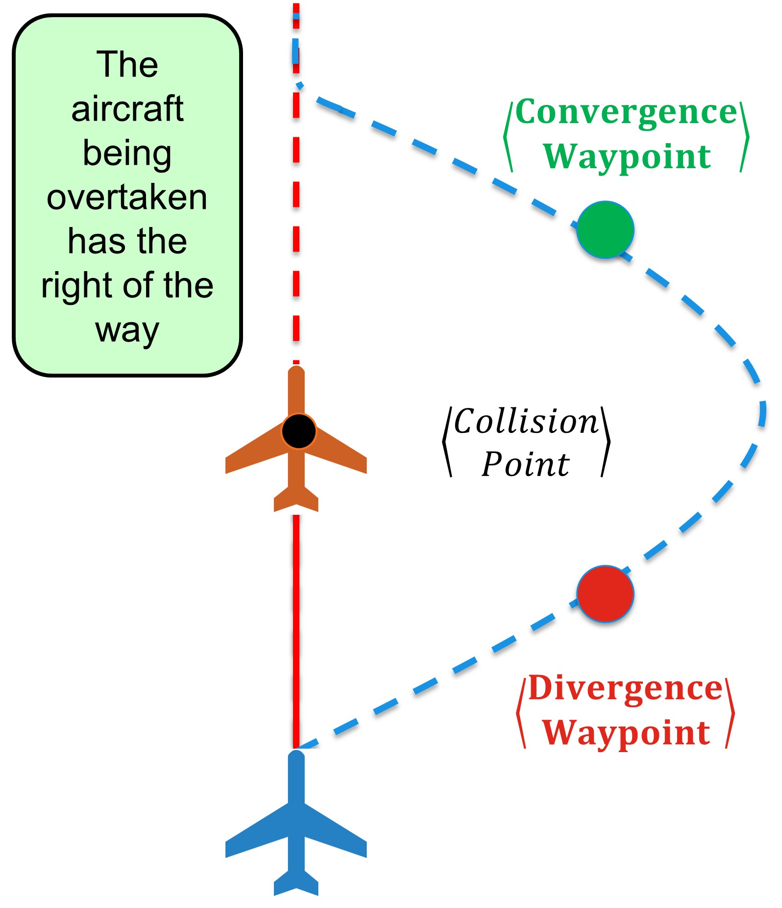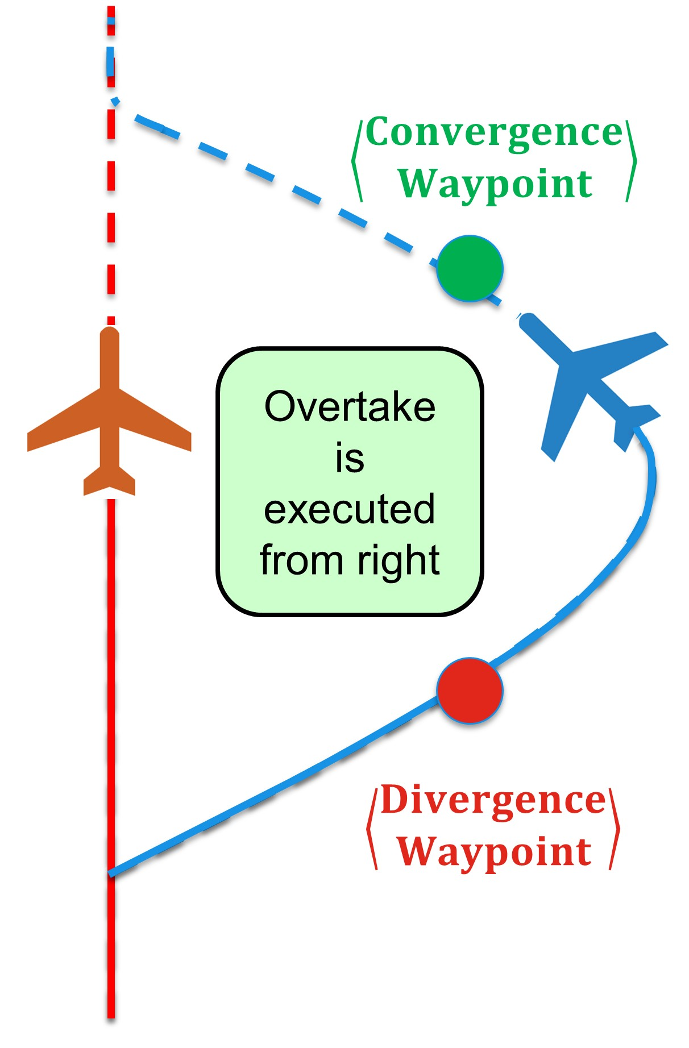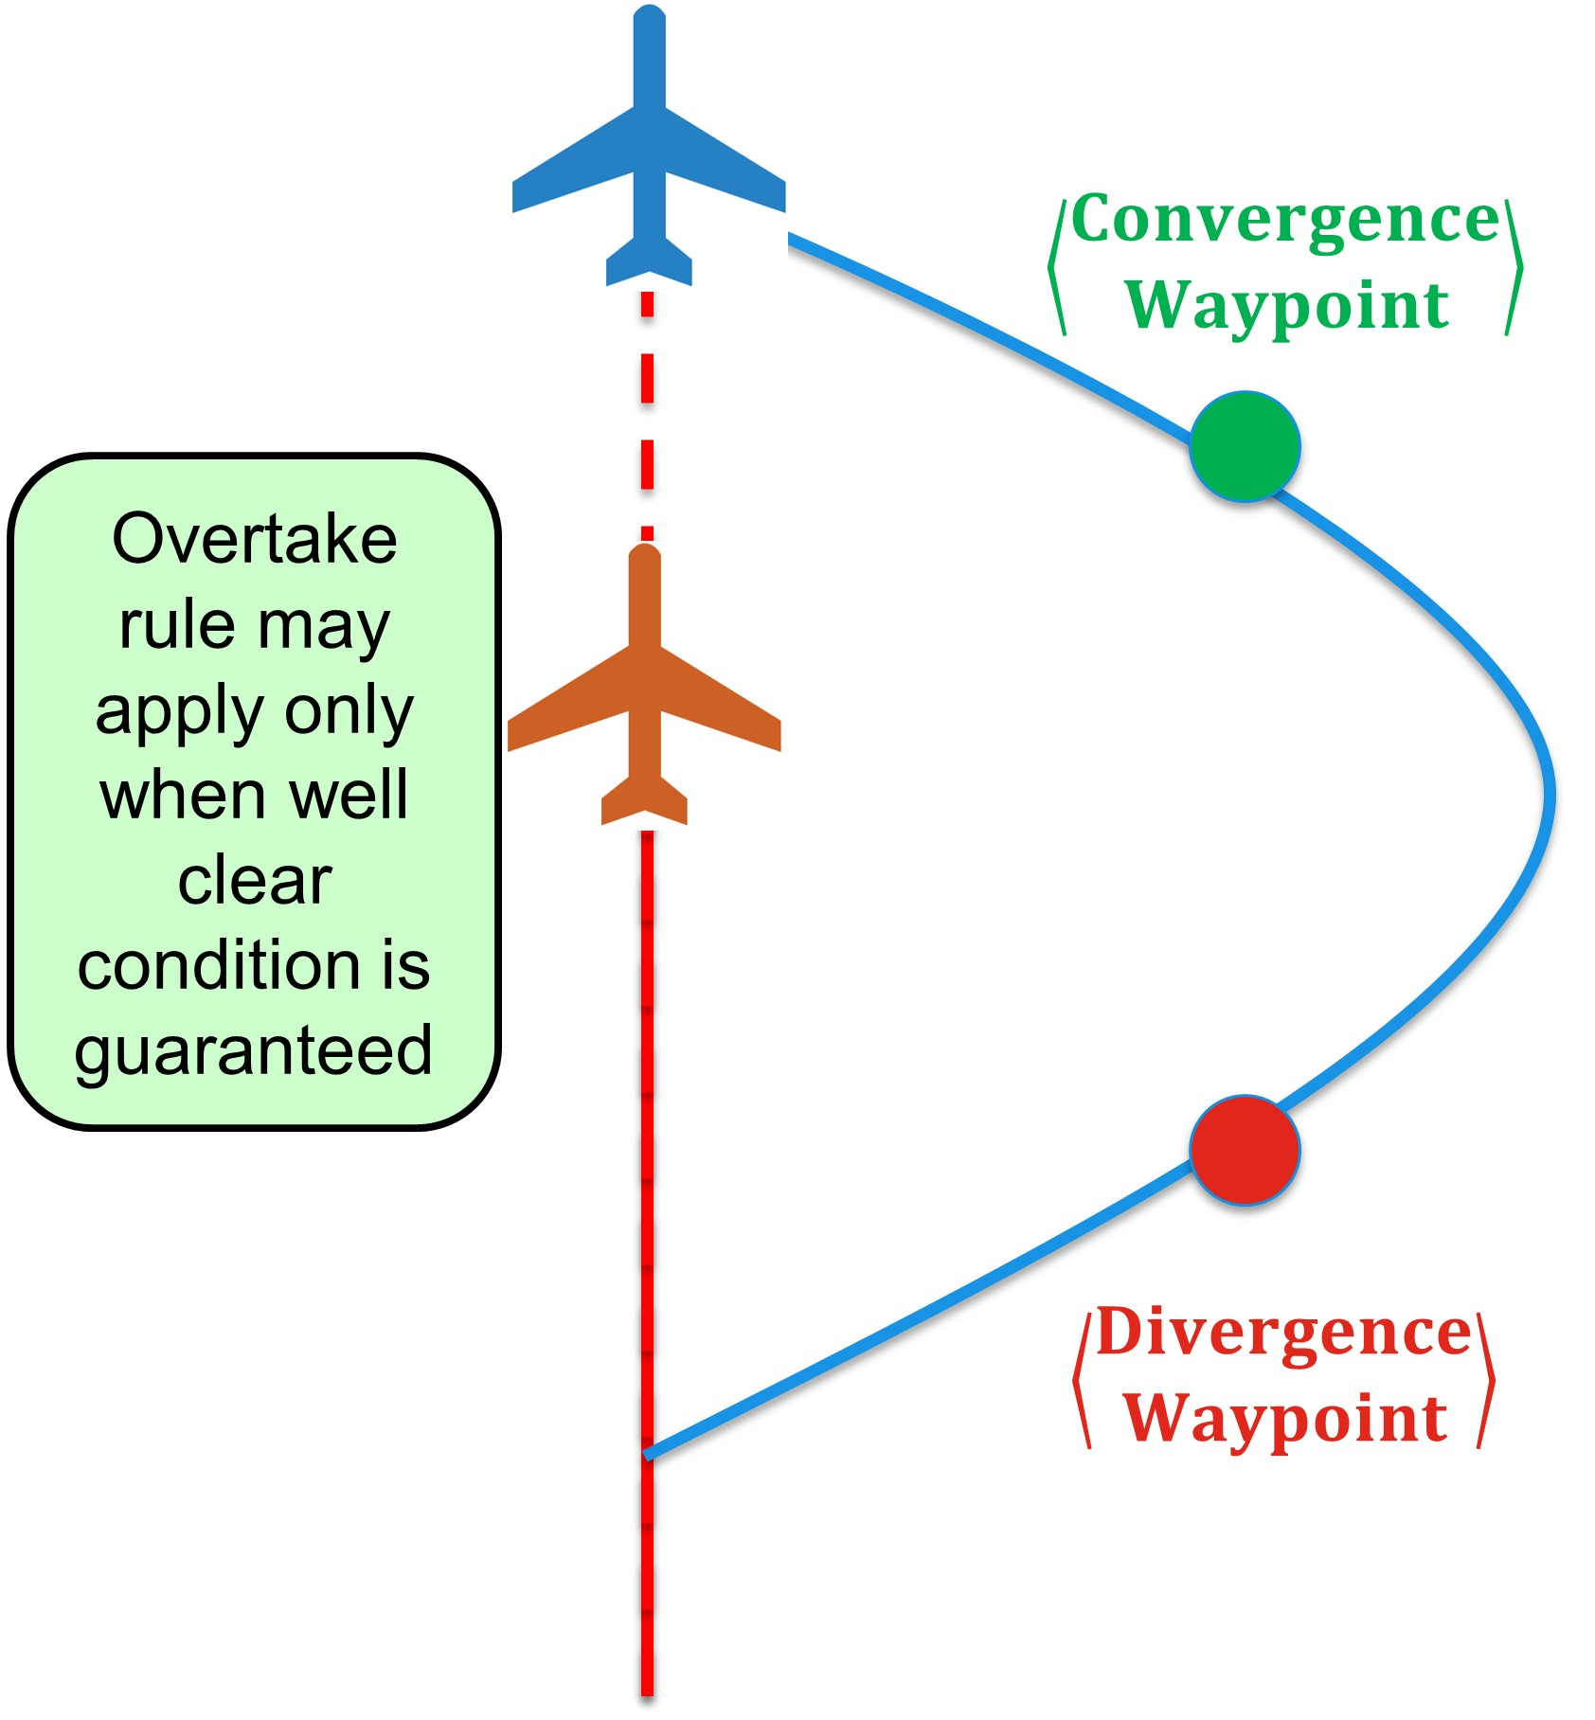

(a) Detection. (b) Resolution. (c) Closing.

Figure 6.6: Overtake maneuver Detection/Resolution/Closing

**IFR:** The *Instrument Fight Rules* in annex 2. [11] and 11. [12] are defining the converging manual in detail:

1. 0◦ ≤ *The angle of Approach <* 130◦ - the minimal planar angle between aircraft position and expected collision point is in the interval [0[
2. *Minimal Detection Range* - given as 2 × *reactionTime* × *speed difference*.
3. *Safety Margin* - during avoidance the overtaking aircraft keeps the minimal distance of *wake turbulence* of overtaken aircraft in own flight altitude.

*Note.* The *Safety Margin* is sufficiently small because speed difference is usually much lesser than in case of *Head on approach*. The *Wake turbulence* can be avoided completely by taking the higher altitude level than overtaken aircraft.

**Triggering events:**

1. *Detection* (fig. 6.6a) - occurs when the distance between *overtaking* (blue) and overtaken (red) is approaching *minimal detection range* or double of *safety margin*. If the performance of *overtaking aircraft* (blue) allows taking *sharp right side to overtake* the *Maneuver starts*, otherwise *overtaking aircraft* (blue slows down) and keeps at least *safety margin distance* to avoid *wake turbulence*.
2. *Resolution* (fig. 6.6b) - *overtaken* (red) is keeping same heading and *speed* during overtake maneuver. The *overtaking* (blue) projects two waypoints: *Divergence* and *Convergence* keeping the required separation minimum during overtake. Then the *overtaking* (blue) diverges heading to *Divergence waypoint*. When the *Divergence waypoint* is reached by *overtaking* (blue) aircraft, it changes to *original heading*.
3. *Closing* (fig. 6.6c) - the *closing* of *Overtake* starts when *overtaking* aircraft (blue) have sufficient lead over *overtaken* aircraft (red). The *overtaking* aircraft (blue) can safely change the heading to the original waypoint.

**Constant Cruising Speed:** Most of the traffic attendants at same flight level have similar (close to constant) cruising speed. Lower flight levels are for slower turbo-prop planes, and higher altitudes are for jet planes. It is stated that this principle will persist even when UAS will be integrated [13, 14, 15] in multiple air-traffic models.

# 6.8.7 Position Notification

**Motivation:** The *position notification* (tab. 6.1) is designed for further *collision case resolution* (sec. 6.8.8). It is similar to ADS-B[1] message information.

The main purpose is to broadcast the *position notification* in *controlled aerospace*. The broadcast for *non-controlled* airspace needs to contain *intruder properties*, *preferred separation mode* and *near-miss margin*.

**Position:** The position is defined in *Global Coordinate System* using GPS for latitude and longitude. The barometric altitude is required for controlled airspace, preferred for non-controlled airspace.

**Heading:** The *Linear Velocity* combined with heading in standard *North-East* coordinate frame is used.

**Flight Levels:** The *flight level* is notified to UTM for *collision detection* purposes. There is a *main flight level* where *aircraft* belong physically. There is a *passing flight level* form which/to which is aircraft emerging [1].

**Aircraft Category:** The aircraft category impacts the prioritization of *role assessment* by UTM/ATM. The following categorization is proposed by *manned aviation pilot community*, from the highest to the lowest right of the way priority:

1. *Manned aviation in distress* [11] - the aircraft with impaired capability switched to emergency mode. The emergency mode is usually acknowledged by the authority in controlled airspace.
2. *Balloon* (manned) [11] - the aircraft with *altitude* control and very slow dynamics implying very low maneuverability.
3. *Glider* (manned) [11] - the aircraft with *full control* but without own *propulsion*. The overall *maneuverability* is good, but the *velocity* changes are impossible with sufficient flexibility.
4. *Aerial towing* (manned) [11] - the towing aircraft usually have *own propulsion* and full maneuverability, the only constraint is *towed load*. The towed load decreases overall maneuverability.
5. *Airship* (manned) [11] - the airship have *own propulsion* and full maneuverability, the constraint is low acceleration/deceleration and huge turning radius.
6. *Other manned aviation* [11] - containing all vehicles with the required level of *airworthiness* for given operational *altitude*. They usually have required maneuverability.
7. *UAS Autonomous* (proposed) [16] - containing all autonomous UAS, the lower flexibility is expected at the beginning of integration.
8. *Remotely Piloted Aerial System (RPAS)* (proposed) [16] - has lesser priority due to the higher response rate of the pilot.

*Note.* This categorization reflects only Pilot community statement; the general priority rule is broken, because maneuverability and vulnerability should always be considered as a key decision factor.

**Maneuverability:** The maneuverability is the real key factor in priority assessment. The components of maneuverability are *maximal/mean acceleration/deceleration*, *climb/ descent rate* and *turning ratio/radius*. The comparison can be made by solving *pursuit problem* using *Reach Sets* [17, 18].

The *Maneuverability categorization* is based on *original aircraft priority categorization* [11] accounting UAS/RPAS as equal to *manned aviation*. The ordered list from the highest to the lowest priority goes as follows:

1. *Impaired control* (Distress aircraft) - any aviation attendant in distress has the priority in case of the conflict occurrence.
2. *Altitude control/No* (Balloon, Hovering aircraft) - the balloon type crafts do not have any type of propulsion, and horizontal movements follow the airflow in given altitude.
3. *Full control/No propulsion* (Gliders of any sort) - the gliders can control their horizontal position, but there are limits to altitude control and acceleration/deceleration.
4. *Full control/Linear propulsion* (Any aircraft of plane type) - the *towing aircraft’s* and *airplanes* belong there; the difference is the *flexibility* of *maneuvering*.
5. *Full control/VTOL capability* (Any aircraft with VTOL) - the *other aircraft* capable of doing on spot turn. The typical representative is *quad-rotor copter*.

There are other aspects like *minimal required* acceleration/deceleration/turn ratio to operate in a selected segment of the *airspace*. These should be specified later by *Minimum Operational Performance Standards* (MOPS).

**Position**

|  |  |
| --- | --- |
| latitude | based on GPS/IMU sensor fusion. |
| longitude | based on GPS/IMU sensor fusion. |
| altitude | barometric altitude *Above Mean Sea Level* (AMSL). |

**Heading**

|  |  |
| --- | --- |
| orientation | orientation in standard North-East coordinate frame. |
| velocity | relative UAS velocity. |

**Flight Levels**

|  |  |
| --- | --- |
| main | flight level, where UAS mass center belongs |
| passing | flight level, during climb/ascend, or when distance of UAS mass center to flight level boundary ≤ 250*ft*. |

**Registration**

|  |  |
| --- | --- |
| registration ID | is unique registration number *to be issued* by local aviation authority for UTM communications purposes. |
| flight code | or mission code is a unique identification number for approved mission plan which is going to be flown by UAS. |
| UAS name | optional UAS identifier to increase human recognition. |

**Categorization**

|  |  |
| --- | --- |
| craft category | ICAO main category, based on vehicle type. |
| maneuverability | secondary categorization is specifying size class, horizontal/vertical turning radius, minimal and maximal cruising speed. |

**Safety margins**

|  |  |
| --- | --- |
| universal | minimal safety margin for any avoidance situation |
| head on | minimal distance from other similar maneuverability class aircraft in case of a head on approach. |
| converging | minimal distance from other similar maneuverability class aircraft in case of the head of converging maneuver. |
| overtake | minimal distance from other similar maneuverability class aircraft in case of overtake maneuver. |
| wake angle | for wake turbulence cone. |
| wake radius | for wake turbulence cone. |

Table 6.1: Time-stamped *position notification* structure.

**Safety Margins:** The *Safety Margin* for *Well Clear Condition* value is based on the *situation*. There is also a *universal safety margin* which guarantees the minimal safety for encountering intruder.

The most prevalent effect is *Wake turbulence, therefore,* *wake turbulence cone* angle [0 ◦ −90◦] and radius.

The *safety Margin* for situation-based avoidance is given by the list of supported maneuvers; there is converging (sec. 6.8.5), head on (sec. 6.8.4), overtake (sec. 6.8.6) safety margins

# 6.8.8 Collision Case

**Collision Case Purpose:** There is a need for detection and tracking of possible *controlled airspace traffic attendants* collisions. The presented *collision case structure* (tab. 6.3) is a minimalist reflection of *ATM* requirements. Following aspects of *collision case* life cycle are explained in this section:

1. *Base terminology* - the definition of *enforcement procedure* and difference between *Resolution* and *Mandate* from UTM authority. The *severity issue* is open.
2. *Calculation of single case for single decision frame* - step by step calculation and threat evaluation. Prequel to the *life cycle*.
3. *Life cycle* gives outlook on how collision case data are handled through a longer period, notably: *Opening*, *collision point handling*, *safety margin handling*, and, *Closure*.
4. *Merge procedure for multiple cases in a single cluster* - the naive *merge procedure* to solve *multiple collision cases* via the *virtual roundabout*.

**Resolution/Mandate Enforcement:** *Enforcement procedure* is consisting from *Threat detection phase* and *Mitigation phase*. The *mitigation phase* is a time interval when *UTM* decision is enforced. The decision the UTM is enforcing is delivered in the form of *Resolutions* and *Mandates*.

*Resolution* is an order from the *UTM* authority which is followed by subjected UAS. The *subjected UAS* can determine own behavior to some extent. When there is an emerging threat or another destructive event, like a new non-cooperative adversary, the UAS is allowed to broke *resolution*.

*A mandate* is an order from the *UTM* authority which can not be broken at any cost. The example of the *mandate*: UAS is flying in the airspace, the passenger in distress needs it to safely land. The UAS must obey mandate even at the event of own destruction.

**Threat Severity Evaluation:** The threat severity evaluation is omitted partially, all threats are considered as equal. All commands from *UTM authority* will be considered as *resolutions*.

**Calculation procedure:** Collision case is calculated for two *Registered UAS systems* in *Unified UTM time-frame*. The *unified UTM time-frame* is a short period in future when the anticipated situations are predicted.

**1st** The *position* and *orientation* are adjusted according to the *mission plan*. Our implementation uses *Movement Automaton* as a predictor:

*adjustedPosition* = *Position*(*Trajectory*(*notifiedState,futureMovements*))

*adjustedOrientation* = *Orientation*(*Trajectory*(*notifiedState,futureMovements*))

(6.2) For other cases standard linear prediction can be used:

*adjustedPosition* = *notificationPosition* × *notificationV elocity* × *timeDifference*

*adjustedOrientation* = *notificationOrientation*

(6.3)

**2nd** The *maneuverability*, *craft category*, *registration ID* are taken from *position notification*.

**3rd** *Collision case check procedure* goes like follows:

1. *Operation space checks* - the controlled airspace and flight level must match for proceeding.
2. *Maneuverability/Category check* - the maneuverability and UAS category must match. If there is mismatch, then the right of the way is forced to the vehicle with higher priority.

**4th** *Linear Intersection test* is designed to calculate *closest distance* and *time* of *linear trajectory projections*, First, for given *velocity* and *position* for UAS1 and UAS2 the helper variables are calculated:

* + 1. = k*velocity*1k2
    2. = 2 ∗ (*velocity*1*T* × *position*1 − *velocity*2*T* × *position*2)
    3. = 2 × *velocity*1*T* ∗ *velocity*2

(6.4) );

* + 1. = k*velocity*2k2 ;
    2. = k*position*1k2 + k*position*2k2 ;

Then the projection parameters can be calculated:

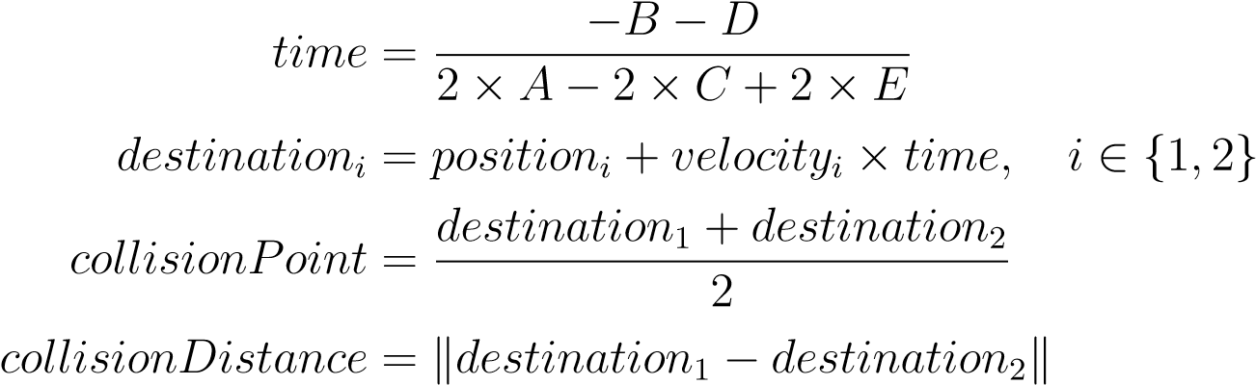 (6.5)

If *time <* 0 the trajectories are diverging from each other (because the closest points already occurred). The procedure ends, the *collision flag* is not raised.

If *time > timeMargin* the trajectories will get close to each other, but in further future and changes are anticipated. The procedure ends, the *collision flag* is not raised.

If 0 ≤ *time* ≤ *timeMargin* the trajectories are converging to each other and distance needs to be checked. If *distance* ≤ *collisionMargin* then *collision flag* is raised and *collision point* is set.

*Note. Collision Margin* is some number which is determined based on aircraft category and maneuverability. Our work defines collision margin as follow:



Where the *safety margin* for every possible situation is evaluated for both *UAS*.

**5th** The *trajectory* intersection is *Movement Automaton* specific collision detection method. Its based on the assumption that *UTM* has the following information from *mission plan*:

1. *UAS state* - not only *position*, *orientation*, and, *velocity* vectors, but other mathematical model parameters mandatory for *movement automaton*.
2. *Movement Automaton* - movement automaton for our UAS system so that UTM can use it in predictor mode.
3. *Future Movements set* - up to reasonable prediction horizon *timeMargin*.

The *Movement Automaton* can be used as trajectory prediction for initial system state and future movements. The prediction function (eq. 6.7).

*Prediction* : *UAS* × *state* × *futureMovements* → [*x,y,z,t*] ∈ R4 (6.7)

*Note.* Then prediction for UAS1 is *Prediction*1, and for UAS 2 *Prediction*2, the predictions are synchronized meaning that time at position *i* is equal in both discrete trajectory matrices.

The *collision distance* for predictor (eq. 6.7) is given as minimal distance of projected synchronized trajectories for UAS1 and UAS2. In our discrete enviroment, the *collision distance* is given as (eq. 6.8).

  

*collisionDistance* = mink*point*1 − *point*2k : ∀*pointpoint*21*,*∈∈ *PredictionPrediction*12*,,* (6.8)

##   *t*1 ∼ *t*2 

If *collisionDistance* ≤ *collisionMargin* condition is met, *collision flag* is set.

The collision point is then calculated as mean of *UAS positions* in prediction at a time when the distance is minimal. The final collision point is arithmetic mean of two positions (eq. 6.9).

(6.9)

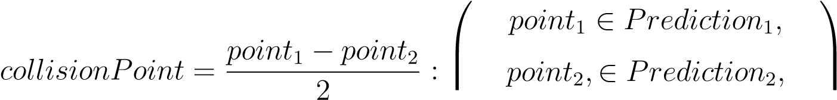  *t*1 ∼ *t*2 at minimal distance

*Note.* Collision point is overwritten by trajectory intersection (specific) method; the *linear intersection* is considered a *general collision detection method*. The collision detection method in future UTM system needs to be determined. The *Trajectory intersection* method presented in this work is one of the possible candidates.

**6th** *Role determination* phase is invoked if and only if previous conditions are met and *collision flag* with *collision point* exists.

There is *adjusted position* of each UAS used as verticals and *collision point* used as a center. The first step is normalization of adjusted position around collision point for both UAS:

*normalizedi* = *adjustedPositioni* − *collisionPoint, i* ∈ {1*,*2} (6.10)

Then the right-hand coordinate system internal angle calculation method is used:

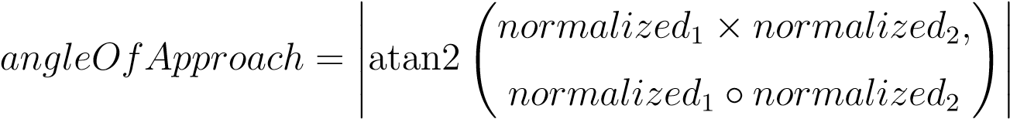 (6.11)

Based on the *angle of approach* the *scenario type* is decided like follows:

1. 130◦ ≤ *angleOfApproach* ≤ 180◦ - the scenario type is set as *Head On Approach*

(sec.6.8.4)

1. 70◦ ≤ *angleOfApproach <* 130◦ - the scenario type is set as *Converging Maneuver*

(sec.6.8.5)

1. 0◦ ≤ *angleOfApproach <* 70◦ and *different speed* - - the scenario type is set as

*Overtake Maneuver* (sec.6.8.6)

Based on *relative position* and *scenario type*, the *avoidance role* like follows:

1. *Head On Approach* enforces following:
   1. The *avoidance role* is set as *RoundAbounting* for both UAS.
   2. None of the *UAS* does have the *Right Of the Way*.
2. *Converging Maneuver* enforces the following:
   1. *UAS* without free right side has a role set as *Converging*.
   2. *UAS* with free right side has the *Right Of the Way*.
3. *Overtake Maneuver* enforces the following:
   1. *Slower UAS* has *Overtaken* role with *Right Of the Way*.
   2. *Faster UAS* has *Overtaking* without *Right Of the Way*.
   3. *Faster UAS* mission plan is altered with *divergence and convergence waypoints*.

**7th** *Safety Margin Calculation* Is invoked when the collision case is *Active*. The *Active Collision Case* in this time-frame means that *Collision Flag* is raised. The *avoidance role* determines *safety margin calculation*.

If *Head On Approach* is case type of *Head collision case* then *safety margin* is calculated as the maximum of the sum of *default* margins or *head on* margins:

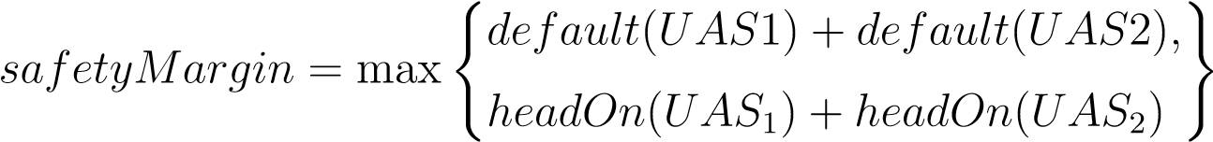 (6.12)

If *Converging Maneuver* is case type of *Head collision case* then *safety margin* is calculated based on *avoiding UAS* as a maximum of opposing UAS *default margin* and avoiding *converging margin*:

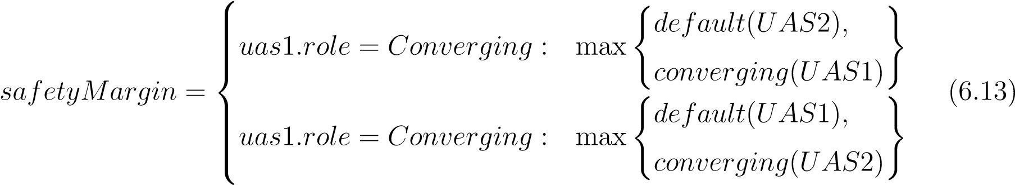

If *Overtake maneuver* is case type of *Head collision case* then *safety margin* is calculated as maximum of *default, overtaking, overtaken* margins of both UAS:

  *default*(*UAS*1)*,default*(*UAS*2)*,*

##  

*safetyMargin* = max *overtaken*(*UAS*1)*,overtaking*(*UAS*2)*,* (6.14)

*overtaking*(*UAS*1)*,overtaken*(*UAS*2) 

**Collision Case Chaining** is procedure when multiple active collision cases for different *time-frame* are chained and creates the time ordered series of *collision cases*. There are two notable instances in the *chain*:

1. *Head Collision Case* - Collision case when the first danger was detected. The notable parameters are *collision point* and UAS *avoidance roles* because these are enforced by the *Rule engine* (sec. **??**). The *head collision case* is first in the chain.
2. *Tail Collision Case* - Collision case when the *collision danger* was not detected.

The *tail collision case* is last in the chain.

*Note.* The *Chaining* of *collision cases* is rather primitive and sensitive for errors/noise.

The *Consistency of Avoidance Maneuver* is ensured by enforcing *head collision case* parameters.

**Data for both attendants**

|  |  |
| --- | --- |
| adjusted position | predicted from previous *position notifications* (6.1) data at the time of *UTM decision frame* start. |
| adjusted orientation | predicted from previous *position notifications* (6.1), *mission plan*, and *expected velocity*. |
| velocity | proclaimed velocity for given *UTM decision time frame*. |
| registration ID | is unique registration number issued by the local aviation authority |
| craft category | from *position notifications* (6.1). |
| maneuverability | from *position notifications* (6.1). |
| mission plan | is acquired from *allowed mission registers* where it has been registered prior UAS flight |
| safety margins | list of all safety margins derived based or craft categorization or overridden by *position notifications* (6.1). |
| avoidance role | is given based on situation evaluation. |
| trajectory prediction | simulated based on *position notification* (6.1) and *mission plan*. |

Table 6.2: Collision case structure attendant data.

**Collision Cases Merge** also known as *Collision Point Adjustment Procedure* purpose it to *merge* multiple collision cases into one general collision case. The clustering is used to identify *airspace congestion events* [19]. Example of *airspace clustering* is given it [20].

The main idea is to *encapsulate multiple collision cases* into one virtual roundabout to ease *traffic load* [21]. The potential risk on *turbo roundabouts* have been outlined in

[22].

There are *active collision cases* in a focused *cluster* in *controlled airspace*. The multiple collision cases can pop up at different *start times,* and they can be active for a different *period*.

The *Collision point* is replaced with the *roundabout center* point (eq. 6.15). The *roundabout center* is calculated as weighted average of *active collision cases* collision points. The *weight* ∈ [0*,*1] depending on severity rating of collision case.



*Note.* The weight in (eq. 6.15) is set to 1 for all time; the weight calculation needs to be determined in future works.

The *smallest circle problem* defined and solved in [23, 24] is used to determine the safety margin in our approach. The *naive approach* determining *roundabout safety margin* is to take the maximum of all open case *safety margins* including default ones (eq. 6.16).

( ) *case.UASi.roundaboutSafetyMargin,*

*safetyMargin* = max *,*

*case.UASi.defaultSafetyMargin*

∀*case* ∈ *Cluster, UASi* ∈ {1*,*2} (6.16)

**Collision case calculated data**

|  |  |
| --- | --- |
| linear intersection | is predicted on attendants *position*, *heading*, *velocity*, based on *maneuverability* certain thresholds are applied to determine safety properties. |
| trajectory intersection | is predicted on attendants *position*, *velocity*, *heading*, and *related mission plans*, based on *maneuverability* certain thresholds are applied to determine safety properties. |
| collision point | is created if there is the risk of medium/short period collision, if head collision case has not been closed, collision point is inherited. |
| adj. collision point | is created if there exists at least one active collision case in the nearby surroundings of this case collision point (cluster). |
| angle of approach(*α*) | is calculated based on attendants *velocity* and *position*, the range is [0 ], it determines *primary avoidance roles*. |
| safety margin | is calculated based on *avoidance roles*, *maneuverability*, collision indicators, and *angle of approach*. |
| margin adjustment | is calculated based on *linked collision cases*, *estimation errors* and *weather*. |
| linked cases | contains a list of collision cases which are active and can have an impact on this *collision case*. |
| head case | is a reference to collision case in the time frame when it was first opened. |

**Collision case indicators**

|  |  |
| --- | --- |
| linear intersection | indicates if there was a safety breach on linear trajectories estimation with the risk of direct collision. |
| trajectory intersection | indicates if there was a breach on trajectory estimation, with the risk of direct collision. |
| well clear breach | indicates if *linear projection* or *trajectory projection* breaches *well clear barrel* in *controlled airspace*. |
| active case | indicates if the case is still open. |

Table 6.3: Collision case structure for given decision time-frame.

# 6.8.9 Weather Case

**Motivation:** The weather, as defined in (eq. **??**), impacts flight and system dynamics; therefore it impacts the *reach set* is impacted. The *weather impact* can be solved by policy application:

1. *Weather Acceptance* - for bigger *UAS* the normal weather impact does not pose a significant risk. The *segmented movement automaton* (def. **??**) with *Weather situation* as the discrete state is used.
2. *Weather Avoidance* - all *weather* impact zones are considered as hard constraints with protective *soft constraint* around.
3. *Combined approach* - depending on the type of impact and declared UAS impact resistance the zones are divined into *soft* and *hard* constraints.

*Note.* This work handles small *UAS* avoidance; these are very sensitive to any weather impact; therefore *Weather impacted areas* will be considered as *hard constraints with soft constraint protection zone*.

The original *weather impact zone* is considered as obstacle body and enforces the body margin.

The surroundings of *weather impact zone* up to *safety margin* distance are considered as *soft constraint zone* (implemented as a bloated polygon).

**Purpose:** The *weather case* (tab. 6.4) is broadcasted by *Airspace Authority* to *impacted area*, each *UAS* then change their mission according to *their maneuvering capabilities*. Each trajectory must lead away from the *constrained area*. The algorithm used for intersection selected based on [25] the selected algorithm *Shamos-Hoey* [26].

**Constrained Area:** Constrained area can be defined as *static* (sec. **??**) or dynamic constraint (sec. **??**). The *constraint center* is defined on horizontal plane like follow:

*ConstraintCenter* = *center* ∈ [*latitude,longitude*] (6.17)

The *Convex Polygon* boundary is defined on horizontal plane, contains at least 3 vertexes:

*ConvexPolygon* = {*pointi* : *pointi* ∈ [*latitude,longitude*]*,i* ≥ 3} (6.18) The *Vertical constraint* is defined as *range of barometric altitude* (Above Mean Sea Level):

*V erticalConstraint* = [*startAltitude,endAltitude*] (6.19)

**Additional parameters** : Following additional parameters with additional purpose can be attached to *Weather Constraint*.

1. *Type* - defines required resistance - moisture, temperature, wind.
2. *Severity* - defines the impact for each *aircraft category*, this is used in soft/hard type assessment.
3. *Duration* - start and end of *constraint* validity, if not defined valid for all *UAS mission time*.
4. *Velocity* - velocity and last position assessment time.

*Note.* Our implementation does not consider the *type* or *severity*. All *weather impact* is considered as a *hard constraint*. The velocity differentiates *static* (= 0)/*moving* (*>* 0) *constraints*.

**Avoidance System:** Resolve similar to *Converging/Overtake Maneuver* depending on the *angle of approach*. The *virtual roundabout* is utilized for *static constraints*; the *intruder model* is utilized for *dynamic constraints*.

**Constrained area**

|  |  |
| --- | --- |
| center position | is given as a geometrical *center point of the boundary*. |
| boundary | is represented as a *convex polygon* on the latitude-longitude plane. |
| start altitude | is lover boundary barometric altitude given at above mean sea level, where given weather factor has a significant impact. |
| end altitude | is upper boundary barometric altitude given at above mean sea level, where given weather factor has a significant impact. |

**Additional parameters**

|  |  |
| --- | --- |
| type(s) | lists weather events are occurring in the *constrained area*. |
| severity list | is recorded for each plane *category* |
| start | indicates when weather constraint was established. |
| expected end | of weather constraint. |
| velocity | indicates if weather phenomenon is moving. |

**Miscellaneous**

|  |  |
| --- | --- |
| previous | reference to *weather constraint* decision time-frame data. |
| impacted | list of possibly impacted attendees (planes which obtained divergence order or warning from UTM). |

Table 6.4: Static/Dynamic weather constraint for given decision time-frame.

# Bibliography

1. ICAO. 4444: Procedures for air navigation services. Technical report, ICAO, 2018.
2. Ingrid Gerdes, Annette Temme, and Michael Schultz. Dynamic airspace sectorization using controller task load. *Sixth SESAR Innovation Days*, 2016.
3. Thomas P Spriesterbach, Kelly A Bruns, Lauren I Baron, and Jason E Sohlke. Unmanned aircraft system airspace integration in the national airspace using a groundbased sense and avoid system. *Johns Hopkins APL Technical Digest*, 32(3):572–583, 2013.
4. Karthik Balakrishnan, Joe Polastre, Jessie Mooberry, Richard Golding, and Peter Sachs. The roadmap for the safe integration of autonomous aircraft. Blueprint for the sky - Airbus, www.utmblueprint.com, sep 2018.
5. Nico Zimmer, Jens Schiefele, Keyvan Bayram, Theo Hankers, Sebastian Frank, and Thomas Feuerle. Rule-based notam & weather notification. In *Integrated Communications, Navigation and Surveilance Conference (ICNS), 2011*, pages O1–1. IEEE, 2011.
6. Thomas Prevot, Joseph Rios, Parimal Kopardekar, John E Robinson III, Marcus Johnson, and Jaewoo Jung. Uas traffic management (utm) concept of operations to safely enable low altitude flight operations. In *16th AIAA Aviation Technology, Integration, and Operations Conference*, page 3292, 2016.
7. Nico Zimmer and Keyvan Bayram. Selective weather notification, March 18 2014. US Patent 8,674,850.
8. Subramanian Ramasamy, Roberto Sabatini, and Alessandro Gardi. Towards a unified approach to cooperative and non-cooperative rpas detect-and-avoid. In *Fourth Australasian Unmanned Systems Conference*, 2014.
9. Subramanian Ramasamy, Roberto Sabatini, A Gardi, and Yifang Liu. Novel flight management system for real-time 4-dimensional trajectory based operations. In *proceedings of AIAA Guidance, Navigation, and Control Conference*, 2013.
10. Branka Subotic, Arnab Majumdar, and Washington Y Ochieng. Recovery from equipment failures in air traffic control (atc): The findings from an international survey of controllers. *Air Traffic Control Quarterly*, 15(2):157–181, 2007.

23

*BIBLIOGRAPHY*

1. ICAO. Annex 2 (rules of the air). Technical report, ICAO, 2018.
2. ICAO. Annex 11 (air traffic services). Technical report, ICAO, 2018.
3. Alexandre Bayen, Pascal Grieder, George Meyer, and Claire J Tomlin. Langrangian delay predictive model for sector-based air traffic flow. *Journal of guidance, control, and dynamics*, 28(5):1015–1026, 2005.
4. Parimal Kopardekar and Sherri Magyarits. Dynamic density: measuring and predicting sector complexity [atc]. In *Digital Avionics Systems Conference, 2002. Proceedings. The 21st*, volume 1, pages 2C4–2C4. IEEE, 2002.
5. MP Helme, K Lindsay, SV Massimini, and G Booth. Optimization of traffic flow to minimize delay in the national airspace system. In *Control Applications, 1992., First IEEE Conference on*, pages 435–437. IEEE, 1992.
6. Confesor Santiago and Eric R Mueller. Pilot evaluation of a uas detect-and-avoid system’s effectiveness in remaining well clear. In *Eleventh UAS/Europe Air Traffic Management Research and Development Seminar (ATM2015)*, 2015.
7. Nikolai Nikolaevich Krasovskij, Andrei Izmailovich Subbotin, and Samuel Kotz. *Game-theoretical control problems*. Springer-Verlag New York, Inc., 1987.
8. NN Krasovskii and AI Subbotin. Game-theoretical control problems. translated from the russian by samuel kotz, 1988.
9. Karl Bilimoria and Hilda Lee. Analysis of aircraft clusters to measure sectorindependent airspace congestion. In *AIAA 5th ATIO and16th Lighter-Than-Air Sys Tech. and Balloon Systems Conferences*, page 7455, 2005.
10. CR Brinton and S Pledgie. Airspace partitioning using flight clustering and computational geometry. In *Digital Avionics Systems Conference, 2008. DASC 2008. IEEE/AIAA 27th*, pages 3–B. IEEE, 2008.
11. M Ebrahim Fouladvand, Zeinab Sadjadi, and M Reza Shaebani. Characteristics of vehicular traffic flow at a roundabout. *Physical Review E*, 70(4):046132, 2004.
12. Raffaele Mauro and Marco Cattani. Potential accident rate of turbo-roundabouts. In *4th International Symposium on Highway Geometric DesignPolytechnic University of ValenciaTransportation Research Board*, 2010.
13. Jack Ritter. An efficient bounding sphere. *Graphics gems*, 1:301–303, 1990.
14. Emo Welzl. Smallest enclosing disks (balls and ellipsoids). In *New results and new trends in computer science*, pages 359–370. Springer, 1991.
15. Jon Louis Bentley and Thomas A Ottmann. Algorithms for reporting and counting geometric intersections. *IEEE Transactions on computers*, (9):643–647, 1979.

*BIBLIOGRAPHY* 25

1. Michael Ian Shamos and Dan Hoey. Geometric intersection problems. In *17th annual symposium on foundations of computer science*, pages 208–215. IEEE, 1976.

1. ADS-B versions and message containment: [https://mode-s.org/decode/adsb/version.html.](https://mode-s.org/decode/adsb/version.html)